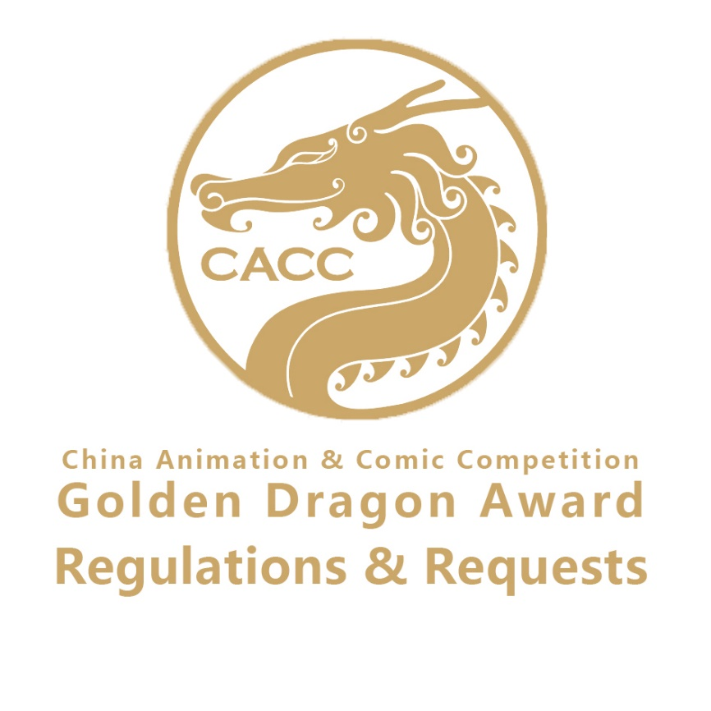
1.ELIGIBILITY & REQUIREMENTS：
1.1 CACC Golden Dragon Award openly solicit contributions from any individual or group both homeland and oversea.
1.2 All entries must be innovative in themes, clear in topic, healthy in contents and norm in words; and very high market value, ideological content and artistic quality are also required.

2. SUBMISSION METHODS & ATTENTION：
2.1 Official submission platform: http://cicfcn.com/cacc_en.
2.2 Click in from the official register access and fill in the application form for 17th China Animation & Comic Competition Golden Dragon Award, uploading to the author’s own cloud storage with the file named in “entry name + author”. The cloud storage permanent shared link should be filled in the form correspondingly. One application form is for one entry. Participants are responsible for loss due to unclear or inaccurate application information.
2.3 Entries must not include watermarks or "samples".
2.4 Entries that contrary to the provisions of the following will be disqualified:
a. Contents inconsistent with the laws and regulations of People's Republic of China;
b. Pornography, violence, blood and other undesirable content;
c. Suspected of plagiarism, copying and copyright infringement;
d. Violation of the CACC Golden Dragon Award competition rules.
2.5 Deadline: July 31, 2020.

3.Awards：
  - China Comic and Animation Award:
Awards | Quota | Rewards(RMB) | Entry Requirements
Theme Award of the Year | One winner | 30,000 | Entries must be original works and keep to the theme of “happy era”, depicting the scene that people strive to create a happy future and share a well-off society.
Theme Award of the Year | Several Nomination Awards | /
  - Comic Integration Awards:
Awards | Quota | Rewards(RMB) | Entry Requirements
Story Comic Award | One Gold Award | 20,000 | Entries must have a complete plot with one or more than one independent chapter(s).
Story Comic Award | Several Silver  Awards | 5,000
Story Comic Award | Several Bronze Awards | 2,000
Story Comic Award | Several Nomination Awards | /
Picture Book Award | One Gold Award | 20,000 | Entries must have a continuous plot with no less than eight pages of painting pictures.
Picture Book Award | Several Silver Awards | 5,000
Picture Book Award | Several Bronze Awards | 2,000
Picture Book Award | Several Nomination Awards | /
Illustration Award | One Gold Award | 20,000 | Entries must have a theme with no less than 6 illustrations.
Illustration Award | Several Silver  Awards | 5,000 | Entries must have a theme with no less than 6 illustrations.
Illustration Award | Several Bronze Awards | 2,000 | Entries must have a theme with no less than 6 illustrations.
Illustration Award | Several Nomination Awards | / | Entries must have a theme with no less than 6 illustrations.
  - Animation Integration Awards:
Awards | Quota | Rewards(RMB) | Entry Requirements
Animated Feature Film Award | One Gold Award | 20,000 | The films must be in no less than 50 minutes and was shown or broadcast at the cinema, on TV channels or the Internet within the year.
Animated Feature Film Award | Several Silver Awards | 5,000
Animated Feature Film Award | Several Bronze Awards | 2,000
Animated Feature Film Award | Several Nomination Awards | /
Serial Animation Award | One Gold Award | 20,000 | The entries must have no less than 2 series and was shown on TV channels or the Internet within the year.
Serial Animation Award | Several Silver  Awards | 5,000
Serial Animation Award | Several Bronze Awards | 2,000
Serial Animation Award | Several Nomination Awards | /
Short Animation Award | One Gold Award | 20,000 | The entry must be an animation in no less than 50 minutes.
Short Animation Award | Several Silver  Awards | 5,000 | The entry must be an animation in no less than 50 minutes.
Short Animation Award | Several Bronze Awards | 2,000 | The entry must be an animation in no less than 50 minutes.
Short Animation Award | Several Nomination Awards | / | The entry must be an animation in no less than 50 minutes.
  - Academy Award
Awards | Quota | Rewards(RMB) | Entry Requirements
Academy Comic Award | One Gold Award | 3000 | The entries should be various forms of comic works (include picture books and illustrations) created by the students during their school time.
Academy Comic Award | Several Silver Awards | 2000
Academy Comic Award | Several Bronze Awards | 1000
Academy Comic Award | Several Nomination Awards | /
Academy Animation Award | One Gold Award | 3000 | The entries must be the comic works created by the students during their school time.
Academy Animation Award | Several Silver  Awards | 2000
Academy Animation Award | Several Bronze Awards | 1000
Academy Animation Award | Several Nomination Awards | /
  - Overseas Awards :
Awards | Quota | Rewards(RMB) | Entry Requirements
Overseas Comic Award | Several | 3000 | All entries should be overseas comic and animation works.
Overseas Animation Award | Several | 3000 | All entries should be overseas comic and animation works.
  - Individual Awards :
Awards | Quota | Rewards(RMB) | Entry Requirements
The Best Comic Technique Award | One | 2000 | All comic and animation entries are qualified to compete the award accordingly.
The Best Comic Scriptwriter Award | One | 2000
The Best Animation Director Award | One | 2000
The Best Animation Scriptwriter Award | One | 2000
The Best Animation Voice Actor Award | One | 2000
The Best Animation Music Award | One | 2000
The Best Utilization of Animation and Comic Award | Several | 2000 | The entries must possess certain communication ability, producing good social benefits and commercial value (animation works such as public welfare, product promotion, game titles, etc.).
  - Committee Recommend Awards :
Awards | Quota | Entry Requirements
Achievement Award | Several | Some comic or animation works, or creators that have a profound impact on society and becomes parts of the collective memories of the public.
Special Award | Several
  - Outstanding Organization Award:
Awards | Quota | Entry Requirements
The Most Powerful Organization Award | Several | The organizations, both comic & animation organizations and academies, mobilize the comic fanciers to take part in the competition, and submit totally more than 20 professional works.
The Best Instructor Award | Several | Specialists or teachers who actively encourage or mobilize contributions, and instruct more than 10 entries, or the entries he/she instructed won the nomination awards or other awards.

Other Requirements for the Comic Works:
- The entries can be in coloured or black and white manuscripts, submitted in JPG format.
- The resolution of traditional comic works must be no less than 300 DPI. The width of scroll comic works must be no less than 800px without limitation to height.
- Feature comics and picture books must be submitted with a cover.
- Hand painted entries must be scanned and submitted electronically.
Other Requirements for Animation Works:
1. Animation entries must be converted to any format of MOV/MP4.
2. Entries must be the official production and trailers are not accepted.
3. All participants must offer more than 5 HD screen-shots and one poster.

4.Review & Award:
4.1 No application of participation fees is charged for this activity.

4.2 Initial Review, re-Review and final review preliminary contest will be organized by Committee to determine the final nomination list.
4.3 Nomination list will be released after the final review, and winners will be announced at the awards presentation. Nominees are required to present at the award ceremony.

5.Copyright Statement & Permission of Usage:
5.1 The entered work must be original and the individual or corporate contestant should have the sole copyright. If it’s proved to be true after investigating the objection against the work raised by a third party, the organizer shall have the right to cancel its qualification for the prize, and the applicant should solely bear the legal liability for breaching the copyright laws.

5.2 The copyright of the entered work is in the applicant’s possession and the committee has the right to use it in the following circumstances (without extra notice and paying remunerations):
a. The entered work and its materials are used for competition promotion;
b . The entered work and its materials are used for award-giving ceremony;
c. The entered work and its materials are used for the event’s exhibitions (including itinerant exhibitions).

5.3 The entered work can be submitted by the organizing committee to apply for related competitions or awards.

6.Consultation:
Participants can consult by the following ways:
E-mail：cicfcacc@vip.qq.com
Tel：+86（0）20-66811966
Twitter：CICF comics festival
Facebook：Xiaomie Long
Working Time：Monday to Friday 9:00-18:00, except holidays

These rules are formulated by the China Animation & Comic Competition Golden Dragon Award Committee. If there is any deficiencies, the committee reserves the final right of interpretation.
Entry submission shall be deemed to agree to all of the above conditions. Participants should be sure to read the relevant rules, and fill out the entry form after submission.

China Animation & Comic Competition Golden Dragon Award Committee
January, 2020

